More information on what you will see at a horse show

The Saddle Seat riding style was created to show off the high neck and action of the American Saddlebred show horse. While it has been adapted for Arabians, Half Arabians, and Morgans, it was initially developed for the Saddlebreds when they gained value as a stylish riding and driving mount.
Here is an explanation of on some of the tack and equipment used by the saddle seat horse and rider and examples of some of the different classes you will see.
Cutback or “Lane Fox” Saddle:
The cutback saddle has a nearly flat seat. It is called a cutback because the pommel is indented 4 inches to make an allowance for the high withers and free movement of the Saddlebreds and other such horses. The saddle has wide flaps to protect the rider's legs from horse sweat and dirt, and a flat seat to allow the rider to best position him/herself so that the horse can look its best.
Pommel
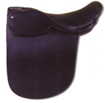
Double Bridle (Weymouth Bridle):
The bridle the Saddlebred wears into the show ring must be the finest quality and of a style that compliments the head of the horse. A full, double, or Weymouth bridle consists of two bits: a snaffle, that has a very fine mouthpiece which allows raising of the head, and a curb, used for tucking in the nose.
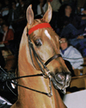
Browband
Curb
Caveson or noseband
Artificial Aids:
Most Saddle Seat riders carry a whip; they should be carried to the inside of the arena. Spurs may also be worn.
Equitation (informal, day) Suit:
This is a required piece of clothing for the rider in many equitation shows. It is a 3-piece suit that consists of a matching jacket and pants with a coordination vest, shirt and tie. Many people may have this kind of suit even if they are not equitation riders or do not show in equitation classes.
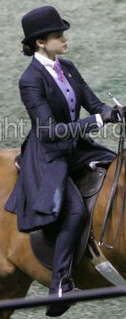
Good example of an Equitation (informal, day) Suit:
Includes derby, tie, coat, jodhpur pants, vest and button down shirt.
Day Coat (Pleasure, Day Jacket):
In performance classes, the rider may choose to show in an equitation suit, or to wear a day coat. A day coat is a jacket that does not match the pants but coordinates with the outfit. A day coat will have a shawl collar instead of a notch collar like on the equitation suit.
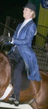
Good example of a day (pleasure) coat:
A royal blue day coat with navy jodhpurs and coordinating vest, shirt and tie, other than the coat the habit has the same parts as an equitation suit.
Tuxedo (Formal Attire):
After 6:00p.m., some classes allow a rider to wear formal attire, with usually consists of a black or dark navy blue long coat with matching satin lapels (shawl collar), top hat, vest or cummerbund, bow tie, and matching jodhpur pants with matching satin strip on outside of pant leg. No formal attire can be worn in pleasure or pleasure equitation classes, but it is commonly seen in evening equitation championships and in park classes for American Saddlebreds, Morgans and Arabians. In a few breed disciplines, though never in equitation, wearing flashy, fancier coats in a formal class in lieu of a matching suit is occasionally fashionable (dressier day coats).
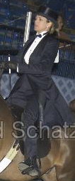

Good example of a Tuxedo:
Includes top hat, bow tie, formal satin 3 button vest, tuxedo shirt, coat and jodhpur pants. Also included are studs for buttons and cuff links.

Driving: The harness used in fine harness and pleasure driving is essentially the same. Usually black with red trim, the harness is often bedecked with shiny patent leather and bright brass hardware. Saddlebreds are often driven with a separate overcheck bit, which aids in setting the correct head carriage.
The buggies used in these classes are quite dissimilar. Fine harness horses pull a four-wheeled carriage, often called a viceroy, and pleasure driving horses and ponies pull a two-wheeled cart, often called a jog cart. There are also road horse and pony classes where they pull a two wheeled cart called a bike. There are many different styles to choose from in either category.

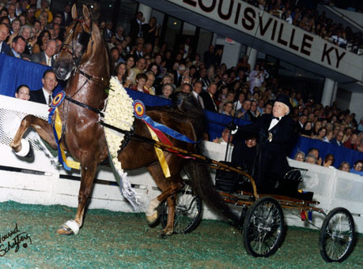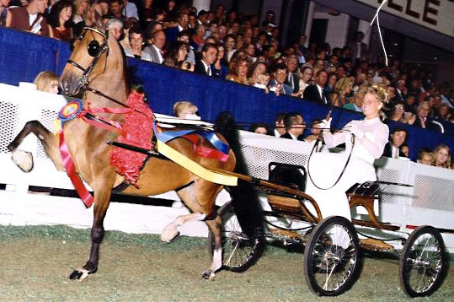
Fine Harness Horse & Buggie

Harness Pony & Buggie

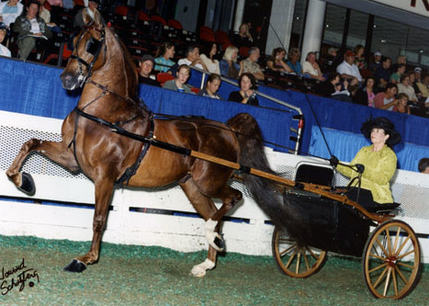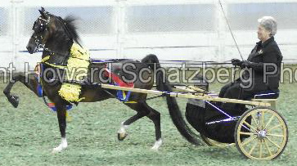
Pleasure Show Cart

Pleasure Pony Cart

Western Pleasure: It is becoming increasing popular to show the saddlebred under western tack. Most shows include western pleasure classes in which they can compete. A western pleasure saddle with silver trim is often used, in a color that best compliments the horse's own. Matching breastplates and bridles complete the look, along with a smart-looking saddle pad.

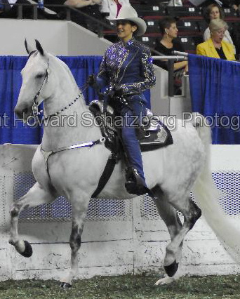

Road Horse and Pony Classes:
Hackney and Harness Ponies: The Hackney is a breed of carriage horse or pony that originated in England and is one of the oldest breeds in the horse kingdom. The Hackney pony cannot be over 14.2 hands (58 inches) in height.
The high stepper of the show ring, these ponies have extreme action both in front and behind. Judged for brilliance and show ring presence, the Hackney presents a picture of sheer daintiness and perfection being driven to a four-wheeled vehicle called a viceroy. The Hackney is shown only at the trot, but in most cases is judged at two speeds - the park trot and the faster "Show your pony," but never should sacrifice form for speed.
Custom demands that the pony be shown with docked tail and mane braided close to the neck. At the trot, the pony should snap the knees and hocks and show high, straight, true action.
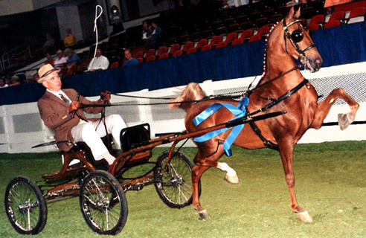
Best example of a show Hackney Pony
The Harness pony has a full, flowing mane and tail and resembles the Saddlebred Fine Harness horse in conformation and way of going. They have grace and high action but cannot exceed 50 inches in height. Like the Hackney pony, they are shown to a viceroy both ways of the ring at the park trot and the faster "Show your pony." (Picture above with buggie example)
The Roadster Division
The Roadster is the speed horse of the show ring, and these driving and riding classes are exciting to watch because of the fast pace set by competitors. Horses must be of the Standardbred breed or the Standardbred type, of attractive appearance, balanced in conformation and with manners which make them safe risk in the ring. There are also classes offered specifically for the popular Roadster ponies under 12.2 hands (50 inches).
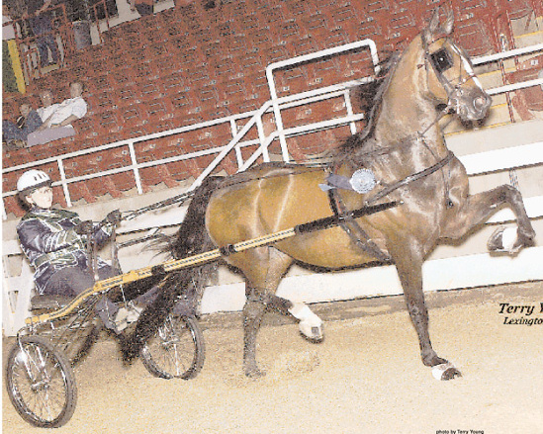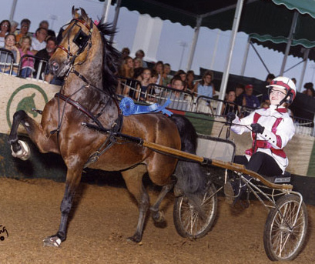
Roadster Horse to Bike

Roadster Pony to bike
All Roadsters are shown at three different speeds of the trot: jog, road gait, and trot at speed; "breaks" (cantering) are penalized. At all speeds, the Roadster should work in form with straight and true action. Animation and show ring presence should characterize the road horse, especially at the jog and road gait.
Roadsters being driven or ridden enter the ring in a clockwise direction at a jog, and are then asked to road gait, then turn to a counterclockwise direction and jog, road gait, and trot at speed.
There are bike (two-wheeled vehicle) and wagon (or buggy) (four-wheeled vehicle) classes. Usually the buggy horse is a larger horse than the bike horse. When Roadsters are ridden under saddle, much enthusiasm is expressed by the crowd.
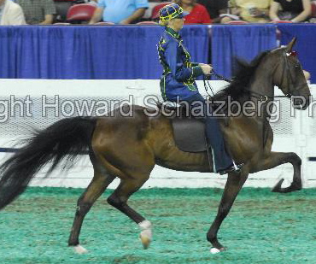
Roadster under saddle

Credits:
Saddle Horse Report
Wikipedia
Kystatefair.com
Doug Shiflet
Howie Schatzberg
Heartland Hackney Farm.com

